The Lord's Teacup Antidote for Spiritual Jealousy
January 16, 2017

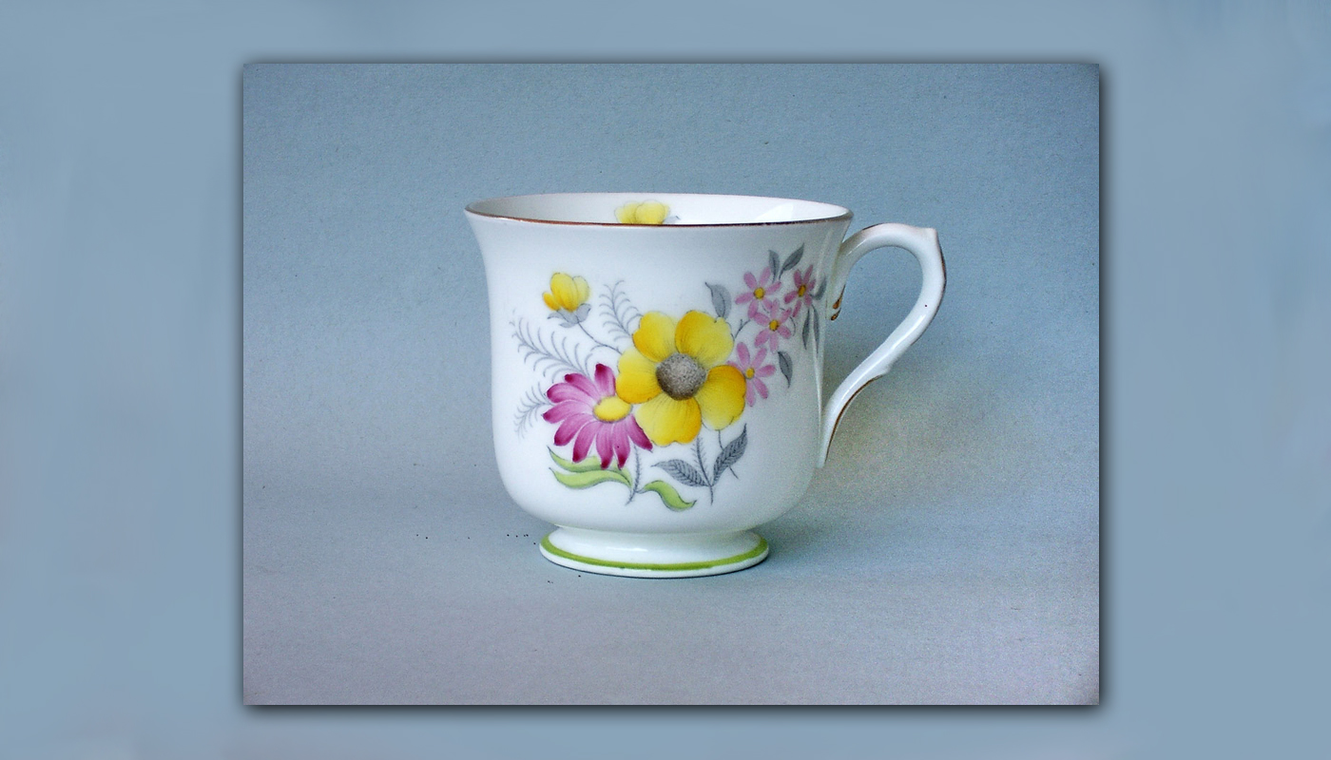
May the sweet presence of Jesus always fill us to overflowing, so that we have no need for the laurels of men.

In this world we will continually be confronted with examples of those who have overcome far more than we have and have stood out in their accomplishments. Sometimes those victories come at a great personal price, but whatever it was in the world that meant so much to them, they were willing to give it up to have their dream.

In the spiritual life, it is no different. We will always meet up with those who love God more than we do, or at least it seems that way. Their sacrifices seem so much greater than ours and perhaps they are. The Lord has given us these saintly examples so we can be inspired and imitate their virtues. But the devils stand by trying to cause a reaction of envy and jealousy.

Dear ones, we have a choice to make: celebrate the great victories of others? Or go away sulking and jealous, even chiding God, "Why not me? What’s so special about them?" What a sad state of affairs. Here God has given us an example to celebrate - and we are resentful and bitter?

I have learned the secret of avoiding this poison a long time ago, though Satan never gives up look for opportunities to temp me. But thanks be to God, I have chosen the broom closet with my Lover. I have chosen to be the one who scrubs His floors and hides in the laundry closet until He comes to see me.

Why? Because I do not care for the world’s laurels or applause. I care only to make My Jesus happy, to have His sweet company, to have all of Him. And so I wait in the broom closet while others are announced in the royal courts and given their crowns.

The dangers that accompany accomplishments are a spirit of Ambition that can enter in and cause us to want things far beyond us. And to want accomplishments more than we want Him. This is something we always have to be on guard about.

I am happy if I can see examples of souls so completely belonging to Jesus, doing great exploits in His name. People like Heidi Baker and others who are anonymous but known well in the spiritual world - both by the evil ones and the holy ones.

Someone once said some of us are tea cups, some are buckets, some are barrels. God created us all at different capacities. The tea cup is small and diminutive and holds very little. The barrel holds an enormous volume of water to fill tea pots and tea cups. But the barrel is never put to the lips of the Lord - only the little tea cup.

I have found the place of supreme happiness and peace in my 'tea cup status'. That doesn’t mean I do not want to grow and be inspired by others who are much bigger and much more dedicated. I want to be who God created to me to be. And somehow the broom closet is more comforting than royal courts. And I know as a child growing up, I always, always shunned competitions. I saw the brutality of those who were better than others, that the things that they did. And I saw what happened to the personalities of those who were gentle and kind, who got involved in competitions - and turned and changed and became vicious in protecting their status. Something about that just makes me really sick.

The littleness of the nobody is more comforting to me than the princes that are accompanied by great fanfare. And some people are called to be princes accompanied by great fanfare and that's wonderful, that's a fulfillment of what God created them to be!

I love this little place. And from this vantage point I can applaud those who are much more accomplished and dedicated. They are doing what I have never been able to do, so far. I can see the good they’ve done for the Lord and applaud them, “Oh, good for you!!! You brought Him joy! You helped to save souls! You healed. Good for you!” I can also say to the Lord Jesus, "Make me willing to be willing, to give more for love of You."

But still, finding my joy in my littleness, my insufficiency is very freeing. I am free to behold the great love the King has for His little handmaiden without the entanglements of ambition and the politics of the royal court. I want to love you, Jesus, and be totally blind to what the world applauds. If I see virtue far beyond my own, I want to applaud it but then return my gaze to Him asking, “Jesus, what more can I do for you?”

At this point, I ran out of things to say and the Lord began to speak.

"You have chosen wisely, My dove. Indeed, you have seen the exploits extraordinaire of My children and rejoiced in them. You have asked nothing more from Me than My love, and how pure is that quality which I adore about you?

"Nonetheless, there are areas yet for you to gain the victory in. Those will come so easily to you if you avail yourself of the broom closet, looking neither to the right nor the left of you, but waiting there in the dark silence for My return.

"Clare, everything hinges on love. A love which you cannot generate for Me. I must endow you supernaturally with this grace of loving Me. But those who have been forgiven much also Love much. You appreciate being rescued from the depravity from which I rescued you. You frequently get lessons in your failures with Me. And for this reason, your love is deep and great, though you do not connect with it until it really matters, and then it brings you to your knees in abject contrition.

"How I wish all of you, My Children, would stay in this place of lowliness, where so little can be lost. Yet many of you aspire to be lofty, high and lifted up. May I say, this is a dangerous state of mind? It is this littleness that pleases Me most. And it is a truth that the tea cup touches My lips, while the barrel waits outside collecting the water.

"O My Children, the world is so very opposite of Heaven. In Heaven all are little and the highest stations are occupied by the lowliest. This is why I bent my knees to wash the feet of My disciples. The greatest among you shall be the servant of all. Not that you should aspire to greatness and take it upon yourself to be serving of all. No, I ask you to be authentic, be who you truly are. Rather, you should aspire to littleness, littler and littler, with nothing worth stealing. This is the safest spiritual posture, being so little that even the demons avoid you, because you are of little worth.

"Not only that, but My angels rush to protect the little ones. To long to be a little one is a worthy ambition. One whose heart is so little, there is only room for Me. One who is so satisfied in this littleness that jealousy never finds a foothold. You become jealous of one greater than you. However, if you long to be littler and lesser, jealousy has no foothold in your being and you are free to enjoy Me to the fullest.

"Yes, My little teacups, stay little. It is My joy to raise you to My lips."

